

**ASBAT EXAMINATIONS BOARD**

**END OF TERM I EXAMINATIONS 2024**

**INTEGRATED SCIENCE**

**PRIMARY SIX**

**Time Allowed: 2Hrs 15 MIN**

**Name:………………………………………………………………………………..**

**Stream:………………………………..**

**Read the following instructions carefully:**

|  |  |  |
| --- | --- | --- |
| **FOR EXAMINER’S USEONLY** | | |
| **Qn. No** | **MARK** | **SIGN** |
| **1 – 10** |  |  |
| **11 – 20** |  |  |
| **21 – 30** |  |  |
| **31 – 40** |  |  |
| **41 – 43** |  |  |
| **44 – 46** |  |  |
| **47 – 49** |  |  |
| **50 – 52** |  |  |
| **53 – 55** |  |  |
| **TOTAL** |  |  |

1. The paper has **two** sections: **A** and **B**
2. Section **A** has 40 questions (40 marks)
3. Section **B** has 15 questions (60 marks)
4. Answer **ALL** questions. All answers to both Sections A

and B must be written in the spaces provided.

1. All answers must be written using a blue or black ball

point pen or ink. Diagrams should be drawn in pencil.

1. Unnecessary alteration of work may lead to loss of marks.
2. Any handwriting that cannot be easily read may lead to

loss of marks.

1. Do **not** fill anything in the boxes indicated for Examiner’s

use only.

***Turn over***

**SECTION A : 40 MARKS**

1. Which plant process is involved in the water cycle?

_______________________________________________________________________

1. Name the breathing organs of a spider.

_______________________________________________________________________

1. What name is given to the upper chambers of the heart?

_______________________________________________________________________

1. Why should land for growing crops be prepared in dry seasons?

_______________________________________________________________________

1. State one way in which pupils can protect themselves from getting skin infections.

________________________________________________________________________

1. How are food stuffs like vegetables and fresh fruits important in one’s diet?

________________________________________________________________________

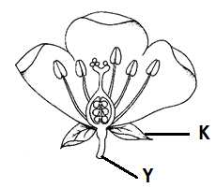**Use the diagram of a flower to answer questions 7 and 8.**

1. Name part marked Y

_____________________________________________

1. How is part marked K important to a flower?

____________________________________________________________________________________________

1. Write one practice used by crop farmers to protect their garden tools from rusting.

_______________________________________________________________________

1. Which malnutritional disease causes ox-bow legs?

_______________________________________________________________________

1. Why should scavenger birds be protected in the environment?

________________________________________________________________________

1. Why should a school have hand washing facilities in different areas of the compound?

________________________________________________________________________

1. Give a reason why crops like rice and sorghum grouped under cereals.

________________________________________________________________________

1. In which way are the ossicles in the middle ear important in the hearing process?

________________________________________________________________________

**The diagram below shows an invertebrate. Study and use it to answer questions 15 and 16**

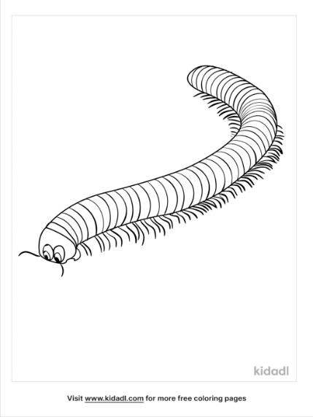

1. Name the invertebrate shown.

_____________________________________________________

1. How is the above invertebrate similar to a cockroach in terms of body structure?

______________________________________________________________________

1. Apart from liver worts, name any other example of a spore producing plant.

______________________________________________________________________

1. State one reason why people keep broilers.

______________________________________________________________________

1. How does the use of energy saving stoves conserve the environment?

_______________________________________________________________________

1. Apart from grinding, mention any other example of mechanical digestion.

_______________________________________________________________________

1. Mention one group of people who make good use of echoes.

_______________________________________________________________________

1. In which way is docking important to an ewe?

_______________________________________________________________________

1. How are the arteries in the body able to withstand blood with high pressure?

________________________________________________________________________

1. Who is a passive smoker?

_______________________________________________________________________

1. Why is a piece of cloth tied slightly above the body part bitten by a snake?

_______________________________________________________________________

1. In which way are cobwebs important to spiders?

_______________________________________________________________________

1. Give one reason why mercury is commonly used in clinical thermometers.

_______________________________________________________________________

1. Name the type of roots that gives a plant extra support.

______________________________________________________________________

1. How best can a P.6 pupil prevent herself from getting AIDS?

______________________________________________________________________

1. Mention one characteristic of a chemical change.

______________________________________________________________________

**The diagram below shows a blood cell. Study it and use it to answer questions 31 and 32**

1. Name the blood cell shown above.

______________________________________________________________________

1. How is the above blood cell adapted to its function?

_______________________________________________________________________

1. In which way does crop rotation control pests in the garden?

_______________________________________________________________________

1. Name the structures which enable the trachea to perform its function.

_______________________________________________________________________

1. Which type of fracture is common in young children?

_______________________________________________________________________

1. State any one way in which alcoholism affects an individual.

_______________________________________________________________________

1. Name the type of root system which forms a large main root.

________________________________________________________________________

1. In which way are cypress different from mushrooms?

________________________________________________________________________________________________________________________________________________

1. How is regular ironing of clothes important in a home?

________________________________________________________________________

1. Name the type of teeth in cats which is well developed.

________________________________________________________________________

**SECTION B**

1. (a) In which part of the digestive system are the following juice secreted
2. Succus entericus_________________________________________________
3. Pancreatic juice___________________________________________________

(b) Name one class of food that boosts the body immunity.

________________________________________________________________________

(c)By what process does food move along the alimentary canal?

________________________________________________________________________

1. (a)Which method of alcohol production involves the presence of heat?

_______________________________________________________________________

(b)State two reasons why people drink alcohol

(i)______________________________________________________________________

(ii)_____________________________________________________________________

(c)Mention any one Ugandan law against alcohol.

_______________________________________________________________________

1. **The diagram below shows a farming practice. Study it carefully and answer the questions that follow.**

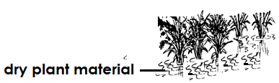

1. Name the farming practice shown above.

_______________________________________________________________________

1. Give two reasons why farmers carry out the above practice.

(i)_____________________________________________________________________

(ii)_____________________________________________________________________

1. Mention any one plant material that can be used during the above farming practice.

________________________________________________________________________

1. (a)Which blood vessels carry blood;
2. Towards the heart_________________________________________________
3. Away from the heart ______________________________________________

(b)Why do some blood vessels have valves?

________________________________________________________________________

(c)Mention one feeding habit that destroys blood vessels.

________________________________________________________________________

1. (a)State any two ways fungi are
2. Useful to people

(i)______________________________________________________________________

(ii)_____________________________________________________________________

1. Harmful to people.

(i)______________________________________________________________________

(ii**)_____________________________________________________________________**

1. **Use the diagram of a stem tuber below to answer questions that follow.**

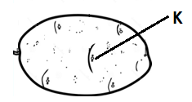

1. Identify the stem tuber shown in the diagram above.

_______________________________________________________________________

1. How is part marked K important on the stem tuber above?

_______________________________________________________________________

1. State the way in which part marked K is protected from mechanical damage.

________________________________________________________________________

1. Apart from the stem tuber above, mention another example of stem tubers.

________________________________________________________________________

1. (a)State two ways of reproducing stored sound.

(i)______________________________________________________________________

(ii)_____________________________________________________________________

(b)Which method of storing sound requires the use of compact discs?

________________________________________________________________________

(c)Apart from a compact disc, mention any one other device used to store sound.

_______________________________________________________________________

1. (a)Apart from the cork, mention two other parts of a thermos flask which helps to prevent heat gain to the flask.

________________________________________________________________________

(b)How does the cork of a thermos flask prevent heat gain to the flask?

________________________________________________________________________

(c)Why should one clean a thermos flask regularly?

________________________________________________________________________

1. (a)State the meaning of germination.

________________________________________________________________________________________________________________________________________________

(b) Mention two conditions necessary for germination to take place.

(i)______________________________________________________________________

(ii)_____________________________________________________________________

1. How are the cotyledons useful ton a germinating bean seed?

________________________________________________________________________

1. **The diagram below shows a foot of a bird. Use it to answer questions that follow.**
2. 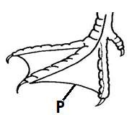Name the part marked P

___________________________________________________

1. To which group of birds does the bird with such foot belong?

____________________________________________________

1. How is part P useful to a bird?

________________________________________________________________________

1. Give one example of such a bird with the foot above

________________________________________________________________________

1. (a)What is air?

_______________________________________________________________________

(b) Mention any two components of air.

(i)______________________________________________________________________

(ii)______________________________________________________________________

(c)Which component of air makes the soil fertile?

________________________________________________________________________

1. (a)Name the digestive juice produced by the following organs of the digestive system.
2. Stomach__________________________________________________________
3. Liver _____________________________________________________________

(b) Mention any one type of digestion that takes place in the mouth.

________________________________________________________________________

(c)Name the part of alimentary canal where absorption of water takes place.

_________________________________________________________________________

1. **The diagram below shows a method of finding volume of irregular shaped objects. Use it to answer the questions that follow.**

100cc 2nd level

80cc

60cc

40cc 1st level

20cc

1. Which method of finding the volume of the stone is use above?

________________________________________________________________________

1. Work out the volume of the stone (2marks)
2. State the use of the string in the above diagram.

_______________________________________________________________________

1. **Study the list of organisms below and use it to answer questions that follow.**

|  |  |  |  |
| --- | --- | --- | --- |
| A | B | C | D |
| Scorpion | Snake | Monkey | Ostrich |

1. State any one similarity between organism C and D

______________________________________________________________________

1. To which group of vertebrates does organism B belong?

______________________________________________________________________

1. Identify the organism that feed its young one on breast milk.

______________________________________________________________________

1. Which of the above organisms protects itself by stinging?

______________________________________________________________________

1. **Match the following mixtures in A with their methods of separating them in B**

**A B**

Flour and iron fillings filtration

Water and cooking oil using a magnet

Rice grains and chuff using a separating funnel

Passion fruit juice and seeds winnowing

decantation

1. Flour and iron fillings _____________________________________________
2. Water and cooking oil _____________________________________________
3. Rice grains and chuff ______________________________________________
4. Passion fruit juice and seeds_________________________________________

***\*\*\*\*GOOD LUCK\*\*\*\****